ACTIVITY 1: Understanding Stack Operations
Subject: Data Structures
Topic: Stacks | Stack Implementation | Basic Stack Problems

Objective:
To help students understand the working of Stack data structure and practice Push, Pop, and Peek operations using step-by-step dry run.

Part A: Conceptual Questions
- Define Stack and explain LIFO principle.
Ans. A Stack is a linear data structure in which insertion and deletion happen only at one end called TOP.
It follows the LIFO (Last In First Out) principle:
- The element inserted last is removed first.

- What is Stack Overflow and Stack Underflow?
Ans. Stack Overflow → When we try to push an element into a full stack.
Stack Underflow → When we try to pop an element from an empty stack.

- Write real-life examples of Stack.

Stack of Plates, Browser Back button.
- What is the time complexity of Push and Pop operations?
O(1)

Part B: Dry Run Activity
Given a stack of size 5. Perform the following operations step-by-step and show the value of TOP after each operation.
Push(10)
Push(20)
Push(30)
Pop()
Push(40)
Peek()

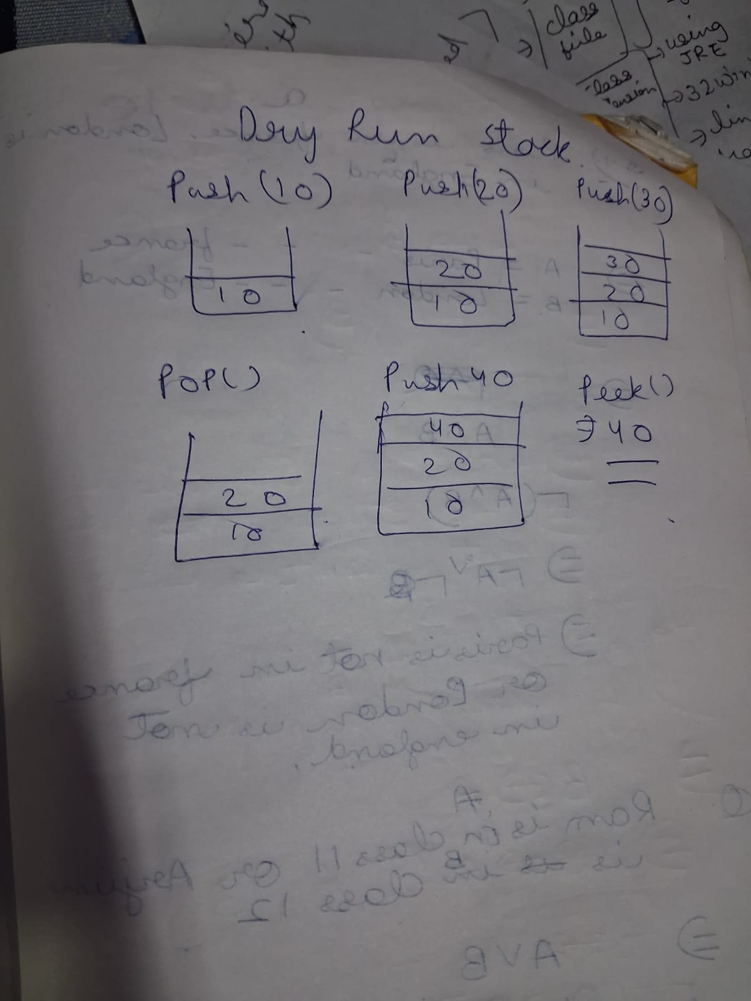

Students must draw stack diagram after each operation.

Part C: Coding Task
Write a Java program to implement Stack using Array. The program should allow user input and perform Push, Pop, and Peek operations.

package capgemini;

class Arrays{
int [] arr;
int size;
int top;
Arrays(int size){
this.size=size;
this.arr=new int [size];
top=-1;
}

void push(int val) {
if(top==size-1) {
System.out.println("stack ovefrlow");
return ;
}
arr[++top]=val;
System.out.println("val pushed"+val);

}
int pop() {
if(top==-1) {
System.out.println("stack underflow");
return -1;

}
else {
int poped=arr[top];
top--;
return poped;
}

}
int peek() {
if(top==-1) {
System.out.println("empty stack");
return 0;
}
return arr[top];
}
void print() {
int i=top;
for(i=top;i>=0;i--) {
System.out.println(arr[i]);

}
}

public class ArrayStack {
public static void main(String [] args) {
Arrays123 a1=new Arrays123(5);
a1.push(10);
a1.push(20);
a1.push(24);
a1.push(45);
a1.pop();
a1.pop();
a1.print();

}
}

}

Part D: Problem Solving Task
Write a program to check whether the given parentheses expression is balanced or not using Stack.

package capgemini;
import java.util.*;
public class Parenthesis {
public static boolean check(String s) {
Stack<Character>st=new Stack<>();
int i=0;

while(i<s.length()) {
if(s.charAt(i)=='(') {
st.push('(');

}
else if(s.charAt(i)==')') {
if(st.empty()) {
return false;
}
else {
st.pop();
}
}

i++;

}

return true;
}
public static void main(String[] args) {
String s;
Scanner sc= new Scanner(System.in);
s=sc.next();
boolean a=check(s);
System.out.println(a);

sc.close();

}

}
Output

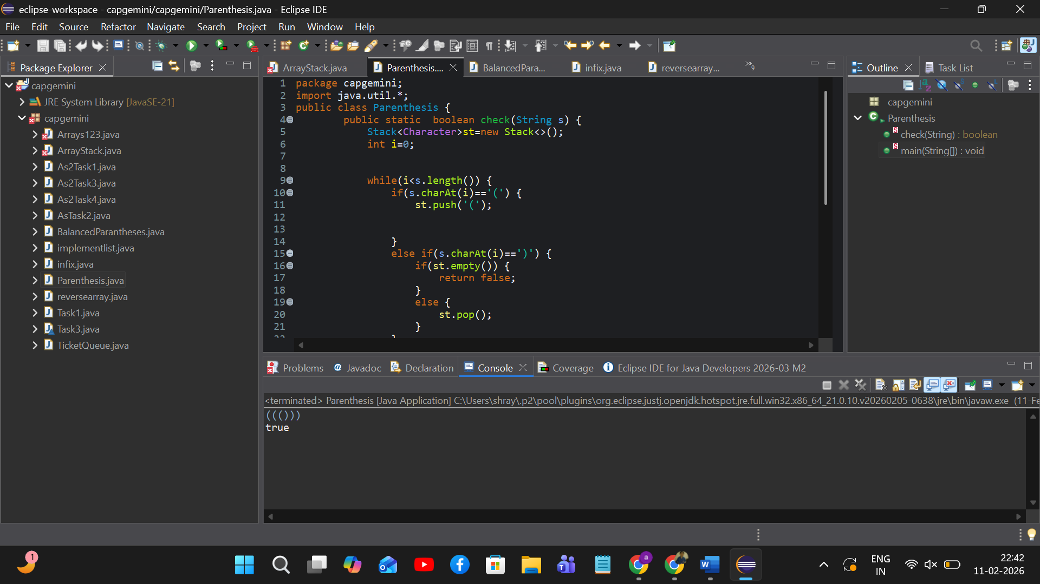

Conclusion

Stack is a linear data structure following LIFO principle.

Push and Pop operations work in constant time O(1).

Stack Overflow and Underflow are important boundary conditions.

Stacks are widely used in expression evaluation and recursion.

Balanced parentheses problem is a classic application of Stack.

Submission Requirements:
• Handwritten dry run with stack diagram.
• Java program code printout.
• Output screenshot.
• Short conclusion (5 lines).

